Green Society Public School
D-
Ratnanagar-7, Sauraha, Chitwan
Annual Examination-2082
Class: Three Time: - 1 hr. F.M.: 25
Sub: HRHG
Name: Roll No.: Sec.:
________________ ______________ OBT.MARKS:
INVIGILATOR EXAMINER
1. Tick the correct answer from the given alternatives. (4×1=4)
a. What is a small family called?
i. Big family iii. Nuclear family
ii. Joint family iv. Large family
b. Which of these is a good value?
i. Honesty iii. Stealing
ii. Lying iii. Stealing iv. Fighting
c. Which one is a communication tool?
i. chair iii. Mobile phone
ii. table iv. Bag
d. Who helps to control traffic?
i. Teacher iii. Traffic police
ii. Doctor iv. Driver
2. Write True or False for the following statements. (4×1=4)
a. Wild animals are also known as wildlife. ( )
b. We should not keep our body and surroundings clean. ( )
c. Nepal is rich in tourist destinations. ( )
d. We should play on the road. ( )
3. Write the names of the following. (6×0.5=3)
a. Two outdoor games:
i. ________________ ii. ________________
b. Two medicinal plants:
i. ________________ ii. ________________
c. Colors of traffic light:
i. ________________ ii. ________________

4. Identify the following pictures. (3×1=3)
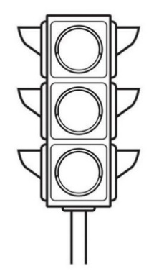

- b. c.

5. Answer the following questions. (4×2=8)
a. How many wards are there in Ratnanagar Municipality?
______________________________________________________________
b. What is cleanliness?
______________________________________________________________
c. Who are tourists?
______________________________________________________________
d. List any two communication devices.
______________________________________________________________
6. Draw a picture of a traffic light.
The End

